
PB-T2/PSQP/1221/B 25-APR-2022
PRE BOARD EXAMINATION 3 – TERM II (2021-2022)
Subject: POLITICAL SCIENCE  Grade: 12 |  | Max. Marks:40  Time:2 Hrs
Name: |  |  | Section: | Roll No:
General Instructions:
- The question paper has 3 Sections A, B & C.
- Section A has 8 questions of 2 marks each. Answer to these questions should be completed within 50 words each.
- Section B has 3 questions of 4 marks each. Answer to these questions should be completed within 100 words each. Answer of map question should be attempted accordingly.
- Section C has 2 questions of 6 marks each. Answer to these questions should be completed within 170 words each.
Section A
1 | What does the term Chouburja Rajneeti signify? |  |  |  | 2
2 | On whose petition Indra Gandhi’s election was declared invalid by the court? |  |  |  | 2
3 | Explain the principle of communitarian socialism propounded by Jaya Prakash Narayan |  |  |  | 2
4 | What is becoming an accepted norm in the entire region of South Asia? |  |  |  | 2
5 | Explain the heterogenous nature of Globalization. |  |  |  | 2
6 | What does the ten stalks of paddy represent in the ASEAN flag? |  |  |  | 2
7 | Why did syndicate support Indira Gandhi as the Prime Minister of India? |  |  |  | 2
8 | What is ASEAN VISION 2020? |  |  |  | 2
Section B
9  1  2  3  4 | Map based question.  In the given outline map of India 4 states have been marked,Identify the states on the basis of the information given below.  The state where Congress did not get majority in 1967 assembly polls,but formed government with the help of others  The state where Janta Dal got majority in 1977  The state where National Democratic Alliance came to power after the Lok Sabha elections 2004.  The state where C Natarajan became the chief minister in 1967.  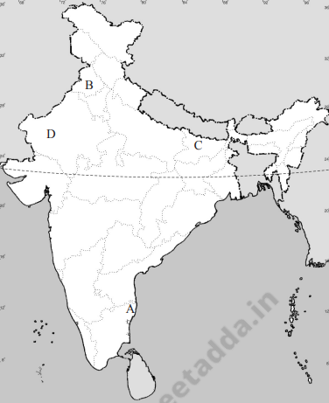 |  |  |  | 4
10 | Describe India China relations from1947 to 1962. |  |  |  | 4
11  1  2 | 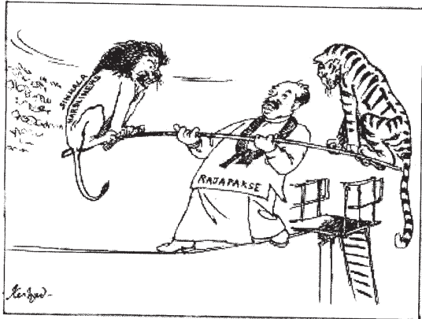  Examine the cartoon and answer the questions  What does lion and the tiger in the cartoon represent?  Which country is depicted in the cartoon and what is the dilemma that the government is in? |  |  |  | 4
Section C
12 | Critically evaluate the impact of the changing role of the state in the developing countries due to globalization.  OR  How did critics view the process of globalization? |  |  |  | 6
13 | Amid sever competition and many conflicts in 1989 a consensus appeared to have among most parties. Explain the point.  OR  Was the declaration of Emergency necessary? Support your answer with suitable arguments. |  |  |  | 6

***

